# CAT18 Script

# Support Guide

Version No: 11.0

# Prepared by: Nikki Bromwich

# Date: 28 February 2012

Table of Contents

Purpose of the Document 3

CAT18 Script Overview 3

CAT18 Script Logic 3

Common Error Messages 3

1. PNR Not found 3

2. Passenger Code Error 3

3. Passenger Select Error 4

4. Segment Select Error 4

5. Fare Basis Error 4

6. Host Errors 5

a. Invalid Modifier 5

b. No Valid Fare 5

# Purpose of the Document

This document is the support guide for the CAT18 Script V11.0. It describes in detail the common errors experienced and the relevant trouble shooting steps.

# CAT18 Script Overview

The script was developed to meet a specific Cathay Pacific (CX), Dragon Airlines (KA) requirement in Hong Kong. It provides a simple-to-use graphical user interface (GUI) and is accessed through an icon on the viewpoint custom toolbar from either Focalpoint or Viewpoint.

The script automates the quoting process and then captures data from the “Note” section of the endorsement field - CAT18 and populates the data into the PNR as unassociated itinerary remarks.

# CAT18 Script Logic

The script has 2 purposes:

1. Creates a filed fare in the PNR
2. Adds endorsement data into the unassociated itinerary remarks field of the PNR

The script uses host entries to perform these tasks based on modifiers agents select in the GUI.

**CAT18 Errors**

There are 2 types of errors found in the script.

1. **Script errors** - which display in a pop-up box. These errors are shown when the script is not permitted to / or can not perform a set action.

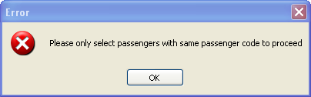

1. **Host errors** - which display in a pop-up box. These occur if the host can not perform the relevant entry.

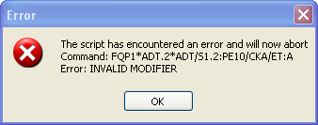

Host errors are always displayed in the following format:

“The script has encountered an error and will now abort.

Host Command: <%CrypticCommand%>

Host Error: <%ErrorReturnedByHost%>"

These are host errors, and would be need to be investigated in host.

# Common Error Messages

## PNR Not found

Issue: This error is returned if the CAT18 icon is pressed and a valid PNR is not displayed on screen.

Fix: Click **OK**, which will exit the script. Retrieve a PNR, then activate the script.

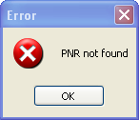

## Passenger Code Error

Issue: This error is returned if the agent is trying to quote multiple PTC’s, which is not permitted in the script.

Fix: Click **OK**. Then use the passenger selection option to select passengers with the same code only.

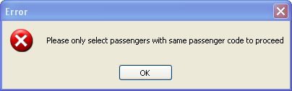

## Passenger Select Error

Issue: This is caused if the agent has not selected any passengers and clicks on the “Get Fare Quote” button.

Fix: Click **OK**, then select at least one passenger to continue.

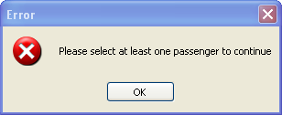

## Segment Select Error

Issue: This is caused if the agent has not selected any segments and clicks on the “Get Fare Quote” button.

Fix: Click **OK**, then select at least one segment to continue.

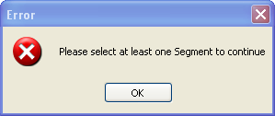

## Fare Basis Error

Issue: This is caused if the agent is using the fare basis modifier and has added 2 or more fare basis codes, which is more or less than the number of segments selected.

Fix: Click **OK**, then correct the number of fare basis added into the text box.

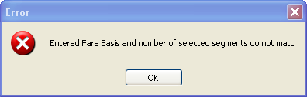

Please note the agent can have 1 fare basis code only as the script will apply this to all segments.

## Host Errors

Host errors are displayed in a pop-up box, which displays both the host command and response. As these are standard host errors, the normal host troubleshooting would be used.

## Invalid Modifier

Issue: The agent has combined modifiers for the quote that are not permitted in the one entry.

Fix: Click **OK** to exit the pop-up, then click on **OK**, to retry the quote. When re-quoting select the correct modifiers.

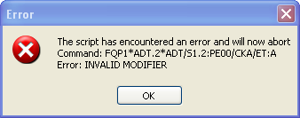

## No Valid Fare

Issue: There is no valid fare found by host for the itinerary the agent is trying to quote.

Fix: Click **OK** to exit the pop-up, then click on **OK**, to retry the quote.

There are quite a few scenarios that could result in “No Valid Fare” being returned, therefore I’ve listed 4 different examples below for reference.

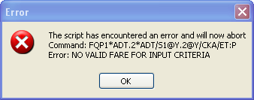 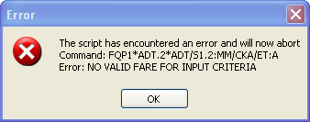

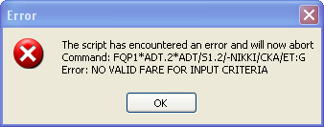 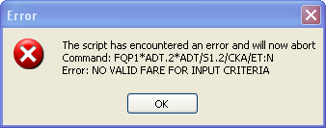

**Please note:** These are standard errors you would find in host when quoting fares, therefore the troubleshooting for these would occur in host and are not script related.

# PNR

The agent will need to refresh their PNR to see the Filed Fare and the Itinerary remarks added by the script.

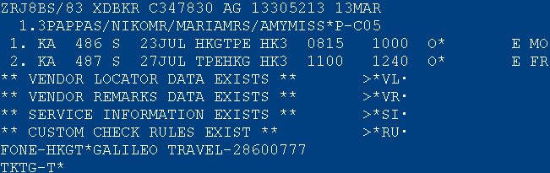

**\*R**

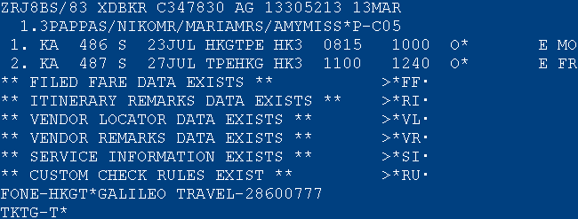

Filed Fare

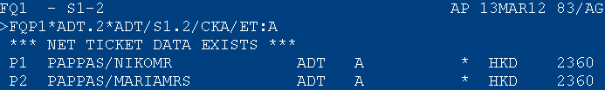

Itinerary Remarks

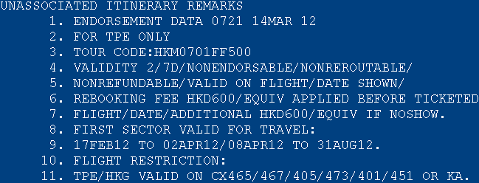

The itinerary remark start with a header which shows “Endorsement Data, time and date” that these were entered into the PNR.